Light Up The Sky

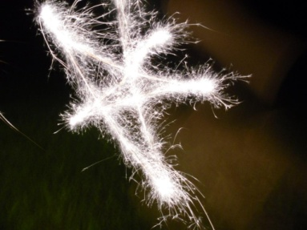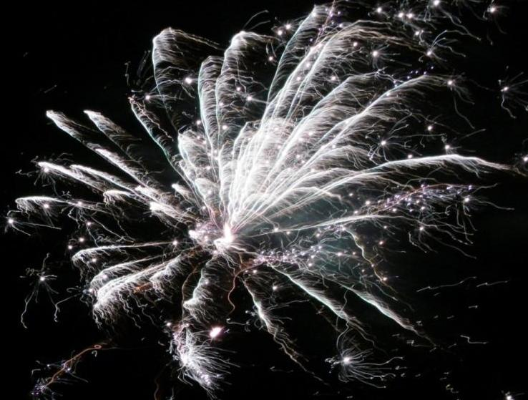

Join Us! The Village Of Grestwood will present its tenth annual Light Up The Sky fireworks extravaganza on *August 8 at 9:00 p.m.* during the end of summer celebration in Douglas Park.

* Pork chop dinners will be sold for $3.00 beginning at 6:00 p.m.
* Bring chairs and blankets
* Admission is free.

Call 555-2983 with questions!